ØØ Explanation :
- We have to exchange the contents of memory locations D000 H and D001 H. Initially we will load the contents of memory location D000 H to the accumulator.
- Store the contents of accumulator in register B.
- Now, load the contents of memory location D001 H to the accumulator. Store this number at memory location D000 H.
- Load the stored number in register B back to the accumulator and store the contents of accumulator to memory location D001 H.
ØØ Algorithm :
Step I : Load the accumulator with the contents of memory location D000 H.
Step II : Copy the contents of accumulator to the register B.
Step III : Load the accumulator with the contents of memory location D001 H.
Step IV : Store the contents of accumulator to memory location D000 H.
Step V : Copy the contents of register B to the accumulator.
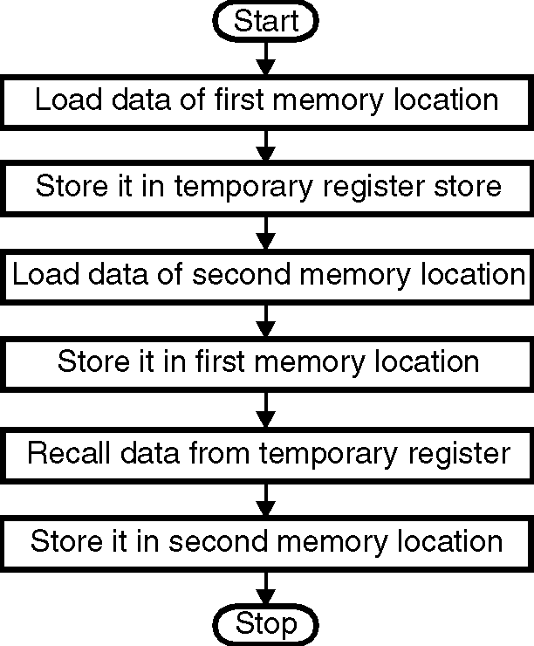
Step VI : Store the contents of accumulator to memory location D001 H.
Step VII : Stop.
ØØ Flowchart : Refer Flowchart 2 and Flowchart 3.
ØØ Program – I :
Instruction Comment
LDA D000 H ; Load data from one memory location
MOV B, A ; Store it in B reg.
LDA D001 H ; Load data from second
; memory location
STA 2000 H ; Store data of second
; memory location to first
; memory location.
MOV A, B ; Recall data of first location Flowchart 2
STA 2001 H ; Store it in second memory location
HLT ; Stop
ØØ Program – II :
Instruction Comment
LHLD D000 H ; Load HL with data at D000 H and D001 H
MOV A, H ; second byte in ACC
MOV H, L ; first byte in H
MOV L, A ; second byte in L
SHLD D000 H ; Store HL
HLT ; Sto

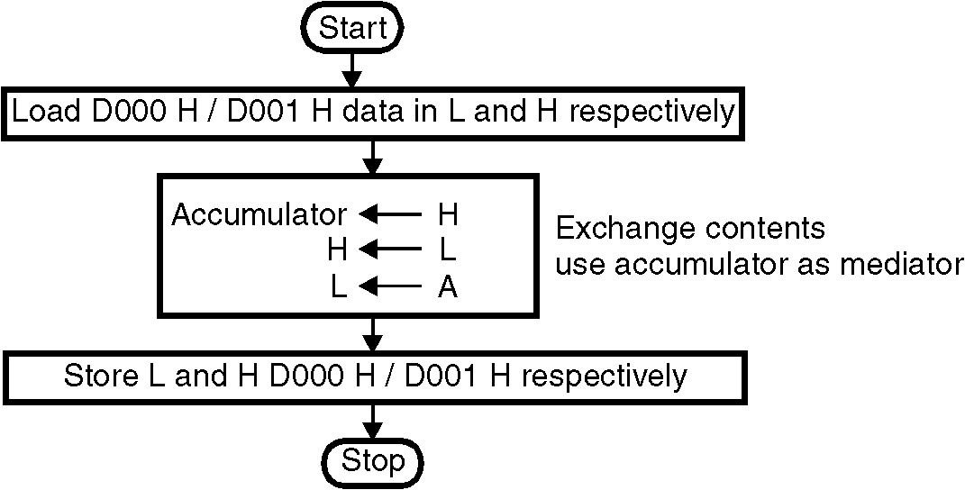
Flowchart 3
ØØ Program – III :
Instruction Comment
LXI H, D000 H ; HL pointing to D000 H
LXI D, D001 H ; DE pointing to D001 H
MOV B, M ; B (HL) (first byte)
LDAX D ; Load second byte in ACC.
XCHG ; Exchange DE and HL pair contents.
MOV M, B ; Store first byte in second location
STAX D ; Store second byte in first location.
HLT ; Stop

